Press Release - Quantum Financial Advisors
Rockville M.D., April 9, 2019

2019 LIBOR Member Ratings
Dear Clients,
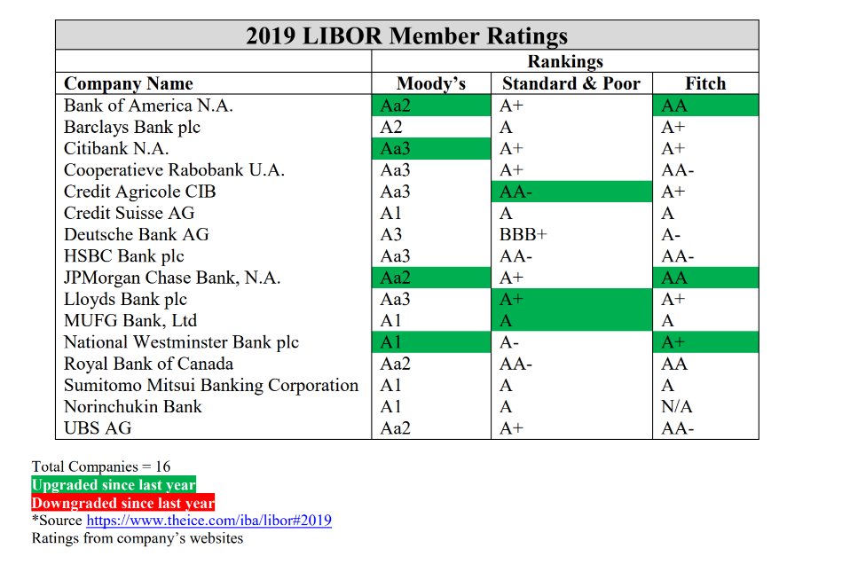
The 2019 credit ratings for the LIBOR member banks have been released. Seven of the sixteen member banks received credit upgrades from at least one rating agency, indicating strength in the top global banks.
Joseph Rinaldi, Matthew Firth, Michael Huber
Quantum Financial Advisors, Inc
51 Monroe Street
Rockville, MD 20850
301-296-6203
If you have any questions feel free to contact customerservice@qfainc.com or our investor service contact Mr. Steven Nunez at 301-296-6203.

Disclosures______________________________________________________________________________________________
This report does not provide individually tailored investment advice. It has been prepared without regard to the individual financial circumstances and objectives of the person who received it. The securities discussed in this report may not be suitable for all investors. QFA recommends that investors independently evaluate particular investments and strategies, and encourages investors to consult with their QFA investment advisor. The appropriateness of a particular investment strategy will depend on an investor’s individual circumstances and objectives.
This report is not an offer to buy or sell any security or to participate in any trading strategy. QFA or its partner or clients may have existing positions in any security discussed in this report. In addition, QFA makes every effort to use reliable, comprehensive information, but we make no representation that it is accurate or complete. QFA has no obligation to inform you when opinions on strategies, sectors, investments and companies change. QFA on an annual basis will offer its updated ADV Part II and disclose what the company and its partner owns. This information shall be accessible to QFA clients only under the client tab of QFAInc.com.
QFA does not receive compensation for any broadcasts or written research that are offered to clients. The firm charges an asset management fee, per hour fee and / or a financial planning fee for services rendered. This report or any portion hereof may not be reprinted, sold or redistributed without the written consent of QFA. All broadcasts are disseminated both electronically and in printed form.

